Computer Science Jeroo Lab 4B – Alley Run Lab Value - 100

Lab Goal: To analyze a problem and involve extensive decision making in creating a solution for the problem. You must determine how many times to hop, when to turn, and most importantly when to stop. You must create commands based on the various requirements of this problem. You must also calculate how many flowers your Jeroo needs to start with so that it may complete its’ chore.
Lab Description: This lab requires you to use a wide variety of if commands. Each cycle of the loop may produce movement on more than 1 conditional at a time. The Jeroo must pick all flowers that it finds, it must replace each net with a flower, and anytime it finds water to the left or the right, it must plant a flower on the side opposite the water. After all of the various conditionals are met, the jeroo should hop once in the direction it is currently facing. This type of programming involves not only using if but using else also. Failure to use the proper commands will mean your Jeroo is at risk as he may end up in the water or the nets.

Starting Screen:
Files Needed:
Jeroo_Lab4B.jsc
AlleyRunIsland.jev

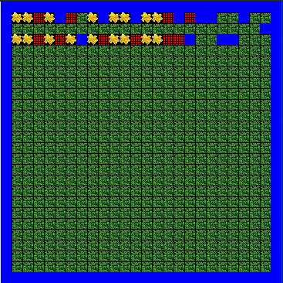
algorithm help

Required Actions
- Pick all flowers it finds
- Disable nets and replace with flowers
- Plant flowers across from each stretch
of water.
- Stop when no longer clear ahead.

Postcondition
- Successful hop through the alley
- Jeroo is not in the nets
- Jeroo is facing East
- Jeroo is facing the water.

Ending Screen:
